print the following pattern

\*

\* \*

\* \* \*

\* \* \* \*

\* \* \* \* \*

Print the following pattern

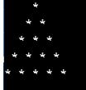

Print the following pattern

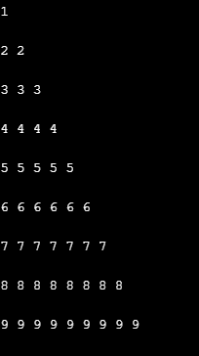

Print the following pattern

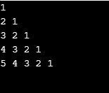

Print the following pattern

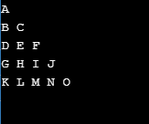

Print the following Pattern

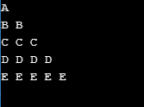

Print the following pattern

1

1. 1

1 2 1

1 3 3 1

1 4 6 4 1